**Model Development Phase**

|  |  |
| --- | --- |
| Date | 21th June 2024 |
| Team ID | LTVIP2025TMID44055 |
| Project Title | Revolutionizing Liver Care : Predicting Liver  Cirrhosis Using Advanced Machine Learning Techniques |
| Maximum Marks | 4 Marks |

**Initial Model Training Code, Model Validation and Evaluation Report**

The initial model training code will be showcased in the future through a screenshot. The model validation and evaluation report will include classification reports, accuracy, and confusion matrices for multiple models, presented through respective screenshots.

**Initial Model Training Code:**

Using SVM to test the model

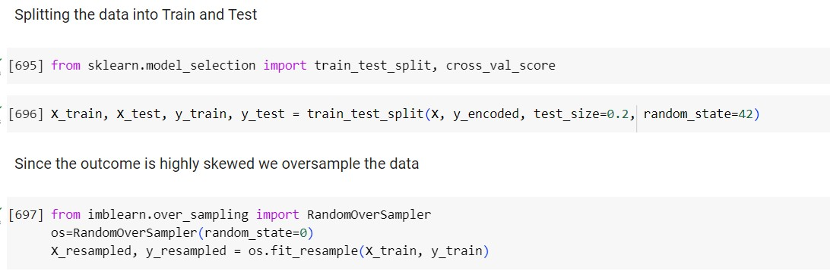

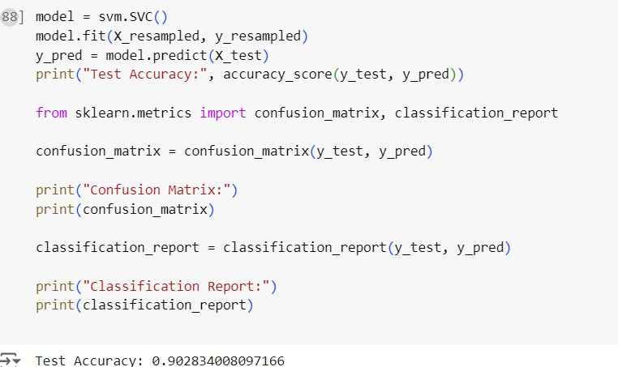

Using Logistic Regression to test the model

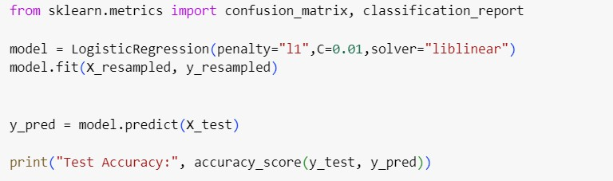

**Model Validation and Evaluation Report:**

|  |  |  |
| --- | --- | --- |
| **Model** | **Classification Report** | **Accuracy** |
| SUPPORT  VECTOR  MACHINE |  |  |
| Model 2 | Screenshot of the classification report | Accuracy Value |
| LOGISTIC  REGRESSION |  |  |

|  |  |
| --- | --- |
| MODEL 1 CONFUSION MATRIX | MODEL 2  CONFUSION  MATRIX |
|  |  |